
CS 181 – AICT
Assignment # 02
Computer Networks and Communication Technologies

––
Student Name: Athar Imran
Student ID: 2604277

Assignment Date: 20th October, 2026
Assignment done: 21st October, 2026
Due Date: 26th October, 2026
Contents
Q1. Data Communication Model 3
Q2. Network Devices 4
Q3. Transmission Modes 5
Q4. Network Topology 6
(a) Topology and diagram 6
(b) Advantage and disadvantage 6
Q5. OSI Model 7
Seven layers in the correct order 7
Match each task to its OSI layer 7

Q1. Data Communication Model
Component | In Sara’s example
Sender | Sara’s mobile phone
Receiver | Hina’s mobile phone
Message | “Class is cancelled today”
Transmission medium | University Wi-Fi
Protocol | WhatsApp uses internet protocols like TCP/IP to transmit data.

Q2. Network Devices
Device |  | Main function | Where it is used
Router |  | It connects different networks and forwards data between them. | Home Wi-Fi network
Switch |  | It connects devices within a local area network (LAN). | University computer lab
Modem |  | It converts signals to enable communication with an internet service provider (ISP). | Home internet connection
Repeater |  | It regenerates or boosts signals to extend network coverage. | Large university building

Q3. Transmission Modes
Example | Transmission mode | Reason
TV broadcast received at home | Simplex | Data travels in one direction, from the broadcaster to the viewer.
Two security guards using walkie-talkies | Half Duplex | Both can communicate, but only one can at a time.
A mobile phone call between two friends | Full Duplex | Both friends can speak & listen simultaneously.
A keyboard sending input to a computer | Simplex | Data normally travels from the keyboard to the computer.

Q4. Network Topology

Topology and diagram
Star topology: All five PCs connect to one central switch.
Central Switch
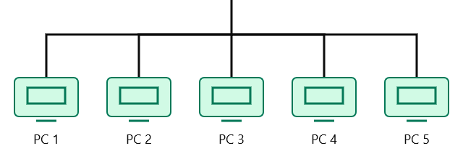

Advantage and disadvantage
Advantage: Failure of one PC or System, doesn’t make the whole network down, other systems can continue their connection.
Disadvantage: Failure of a central switch makes the entire network disconnected. A bus network does depend on a central switch.

Q5. OSI Model

Seven layers in the correct order
- Physical - Layer 1
- Data Link - Layer 2
- Network - Layer 3
- Transport - Layer 4
- Session - Layer 5
- Presentation - Layer 6
- Application - Layer 7

Match each task to its OSI layer
Task | OSI layer
(i) Sending bits as signals through a cable or Wi-Fi | Physical (Layer 1)
(ii) Finding the best path using IP addresses | Network (Layer 3)
(iii) Making sure all parts of a file arrive complete and in order | Transport (Layer 4)
(iv) Opening a website in a web browser (HTTP) | Application (Layer 7)

